**DAILY ONLINE ACTIVITIES SUMMARY**

|  |  |  |  |  |  |  |  |  |
| --- | --- | --- | --- | --- | --- | --- | --- | --- |
| **Date:** | **11-07-2020** | | | | | **Name:** | **Anix Jugal D’Cunha** | |
| **Sem & Sec** | **8 sem , A sec** | | | | | **USN:** | **4AL16CS013** | |
| **Online Test Summary** | | | | | | | | |
| **Subject** | | **Not Conducted** | | | | | | |
| **Max. Marks** | | **--** | | **Score** | | | **--** | |
| **Certification Course Summary** | | | | | | | | |
| **Course** | **CSS3 and Bootstrap for Absolute Beginners** | | | | | | | |
| **Certificate Provider** | | | **Udemy** | | **Duration** | | | 3 hours |
| **Coding Challenges** | | | | | | | | |
| **Problem Statement:** Java Program To Calculate CGPA Percentage. | | | | | | | | |
| **Status: Competed** | | | | | | | | |
| **Uploaded the report in Github** | | | | | **yes** | | | |
| **If yes Repository name** | | | | | **alvas-education-foundation/dcunhaanixjugal** | | | |
| **Uploaded the report in slack** | | | | | **yes** | | | |

Online Test Details: (Attach the snapshot and briefly write the report for the same)

**Not Conducted**

Certification Course Details: (Attach the snapshot and briefly write the report for the same)

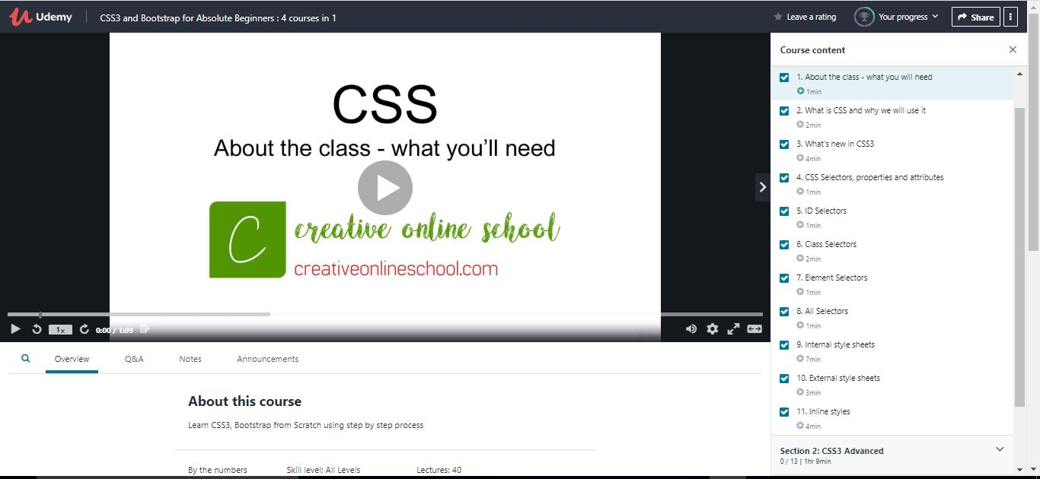

Coding Challenges Details: (Attach the snapshot and briefly write the report for the same)

## Program-> Java Program To Calculate CGPA Percentage.

|  |
| --- |
|  |

**class CGPA**

**{**

**public static void main(String args[])**

**{**

**Scanner sc=new Scanner(System.in);**

**System.out.println("Enter number of subjects");**

**int n=sc.nextInt();**

**double[] marks=new double[n];**

**System.out.println("Enter marks");**

**for(int i=0;i<n;i++)**

**{**

**marks[i]=sc.nextInt();**

**}**

**double cgpa,sum;**

**sum= cgpaCalculation(marks);**

**cgpa=sum/n;**

**System.out.println("cgpa="+cgpa);**

**System.out.println("percantage from cgpa="+cgpa*9.5);**

**}**

**static double cgpaCalculation(double marks[])**

**{**

**double sum=0;**

**double grade[]=new double[marks.length];**

**for(int i=0;i<marks.length;i++)**

**{**

**grade[i]=(marks[i]/10) ;**

**}**

**for(int i=0;i<marks.length;i++)**

**{**

**sum+=grade[i];**

**}**

**return sum;**

**}**

**}**

**Output:**

**Enter number of subjects**

**5**

**Enter marks**

**100**

**98**

**78**

**48**

**59**

**cgpa=7.659999999999999**

**percantage from cgpa=72.77**

**output:2**

**Enter number of subjects**

**6**

**Enter marks**

**90**

**90**

**90**

**90**

**90**

**90**

**cgpa=9.0**

**percantage from cgpa=85.5**